**BLUE Cake Shop** is a small cake shop. Mr. Krauser, the manager of BLUE Cake Shop, wants to change their cashier system to be paperless. He needs a program that can handle his cake shop transaction. He asks you as a skillful programmer to make the program with these descriptions:

Program always shows List of Cakes which contains No, Cake Code, Cake Name, Available, and Price of the available cakes. The List of Cakes:

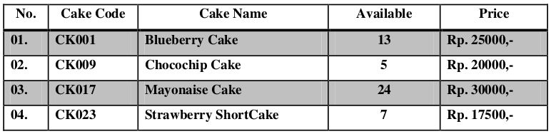

Program consists of 3 menus:

1. Sell
2. Add Stock
3. Exit

* If user chooses Sell, then:
  + Ask user to input “cake code” he/she wants to sell.
  + The “cake code” must consist of 5 characters and be available in the list of cakes. If user inputs the “cake code” other than the ones in the list, the program will show the message:

“--- The Cake Code doesn‟t exist ---” and ask user to input again.

The “cake code” is case sensitive.

* + Then ask user to input the quantity that he/she wants to sell.
  + The quantity must be between 0 and x, where x = [the quantity available of chosen cake].
  + The user cannot sell the cakes more than the quantity available on the list. If user tries to do so, show the message “...The quantity of cake is not enough...”
  + If user succeeds to sell, then show message:

“Total Price is: Rp [price of cake],- x [quantity of cake] = Rp [total price],-”

“--- Thank You ---”

Then subtract the available cakes with the quantity of cake that has been sold.

[available cakes] = [available cakes] - [quantity of cakes that has been sold]

If user chooses Add Stock, then:

* Ask user to input the “cake code” he/she wants to add to the list.
* The “cake code” must consist of 5 characters and be available in the list of cakes. If user inputs the “cake code” other than the ones in the list, program will show message

“--- The Cake Code doesn‟t exist ---” and ask user to input again. The “cake code” is case sensitive.

* Then ask user to input the quantity.
* Validate the quantity of cake must be between 1 and 10.
* If user succeeds to add stock, then show message

“--- Adding Stock Success ---”

* Then add the available cakes with the quantity of cake that has been added.

[available cakes] = [available cakes] + [quantity of cakes added]

If user chooses Exit, then the program ends.

**Print Screen of Main Menu**

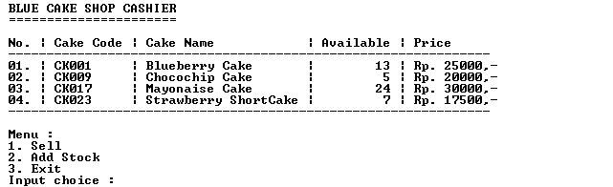

**Print Screen of Sell Menu (Menu 1)**

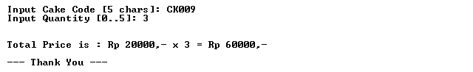

**Print Screen of Add Stock (Menu 2)**

